DNA Extraction from Strawberries Lab Questions
Pre-Lab Questions:
- Do strawberries have DNA? Why do you think so? (Explain your decision- why might a strawberry not need DNA or need DNA?)

- What do you think the Extraction Buffer will do to the strawberry cells? Read the instructions below to help you decide.

During-Lab Questions:
- Do you see anything in the tube that might be strawberry DNA? If so, where is it? Describe its appearance.

- Try to stretch it out- how long (cm) can you get it?

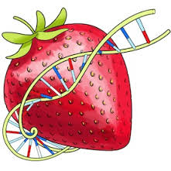

Go further: You can try using this DNA extraction activity on lots of other unprocessed foods or plants- Grab some oatmeal or kiwis from the kitchen and try it again! Which foods give you the most DNA?
Conclusions and Analysis
1. It is important that you understand the steps in the extraction procedure and why each step was necessary. Each step in the procedure aided in isolating the DNA from other cellular materials. Match the procedure with its function:

PROCEDURE FUNCTION
A. Filter strawberry slurry through cheesecloth ___ To precipitate DNA from solution
B. Mush strawberry with salty/soapy solution ___ Separate components of the cell
C. Initial smashing and grinding of strawberry ___ Break open the cells
D. Addition of ethanol to filtered extract ___ Break up proteins and dissolve cell membranes

2. What did the DNA look like? Relate what you know about the chemical structure of DNA to what you observed today.

3. Explain what happened in the final step when you added ethanol to your strawberry extract. (Hint: DNA is soluble in water, but not in ethanol)

4. A person cannot see a single cotton thread 100 feet away, but if you wound thousands of threads together into a rope, it would be visible much further away. Is this statement analogous to our DNA extraction? Explain.

5. Why is it important for scientists to be able to remove DNA from an organism? List two reasons.

6. Is there DNA in your food? ________ How do you know?

DNA Extraction from Strawberries Lab Instructions
Materials per student group (C)
• 1-3 strawberries (about the volume of a golf ball). Frozen strawberries should be thawed at room temperature.
• 10 ml DNA Extraction Buffer (soapy salty water) in a graduated cylinder
• About 20 ml ice cold 91% or 100% isopropyl alcohol in a beaker
• 1 Ziploc™ bag
• 1 clear test tube (leave it in a beaker to stand it up)
• 1 funnel lined with a water-moistened paper towel
• 1 coffee stirrer or pipet
Procedure:
1. Remove the green sepals from the strawberries if present. Throw away in the trash can! (Seat B)
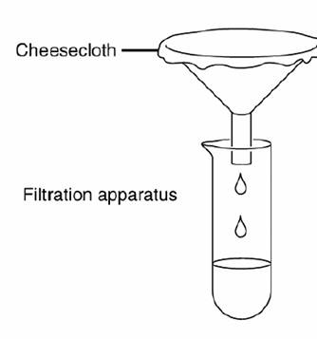
2. Place strawberries into a Ziploc (TM) bag and seal shut. (A)
3. Squish for 1-2 full minutes to completely squash the fruit. (D)
4. Add 10 ml DNA Extraction Buffer (soapy salty water) to the bag and reseal. (C)
5. Squish for a few more minutes. Try not to make a lot of soap bubbles. (B)
6. Set up the filtration putting the test tube, funnel and paper towel like shown in the image to the right (A):
7. Filter the contents of your Ziploc bag through the moistened paper towel and wait for the liquid to collect in the bottom of the test tube.
Do NOT squeeze the paper towel! WAIT until you collect about 3 ml liquid. You may have to pour in stages while you wait for it to filter through. While you wait, start the questions at the end of the lab. (C)
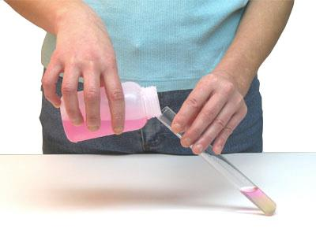
8. Measure out/Make sure you have 20 mL isopropyl alcohol in a beaker. (C)
9. Carefully and AT AN ANGLE add 20 ml ice cold isopropyl alcohol to the strawberry liquid in the bottom of the tube. Pour the isopropyl alcohol carefully down the side of the tube so that it forms a separate layer on top of the strawberry liquid- DO NOT MIX, it should look like this: (B)
10. Watch for about a minute. What do you see? You should see a white fluffy cloud at the layer “interface” between the two liquids. That’s DNA!
These fibers are thousands and millions of DNA strands- All this FOUND in just ONE or TWO Strawberries! Imagine how much DNA is inside YOU!
13. Rinse your funnel and test tube then return the glassware to your tray. (C)
14. Put the Ziploc bag and paper towel in the trash can. (B)
15. Wipe down your station with wet paper towels for any spills. Dry. (D)
16. Check the floor for spills, clean and throw away all towels or trash at your station. (A)

