CRISPR Gene Editing: Human patient treated with CRISPR gene editing for the first time
Chinese researchers hope the tool will help fight cancer
By Michael Koziol November 17, 2016

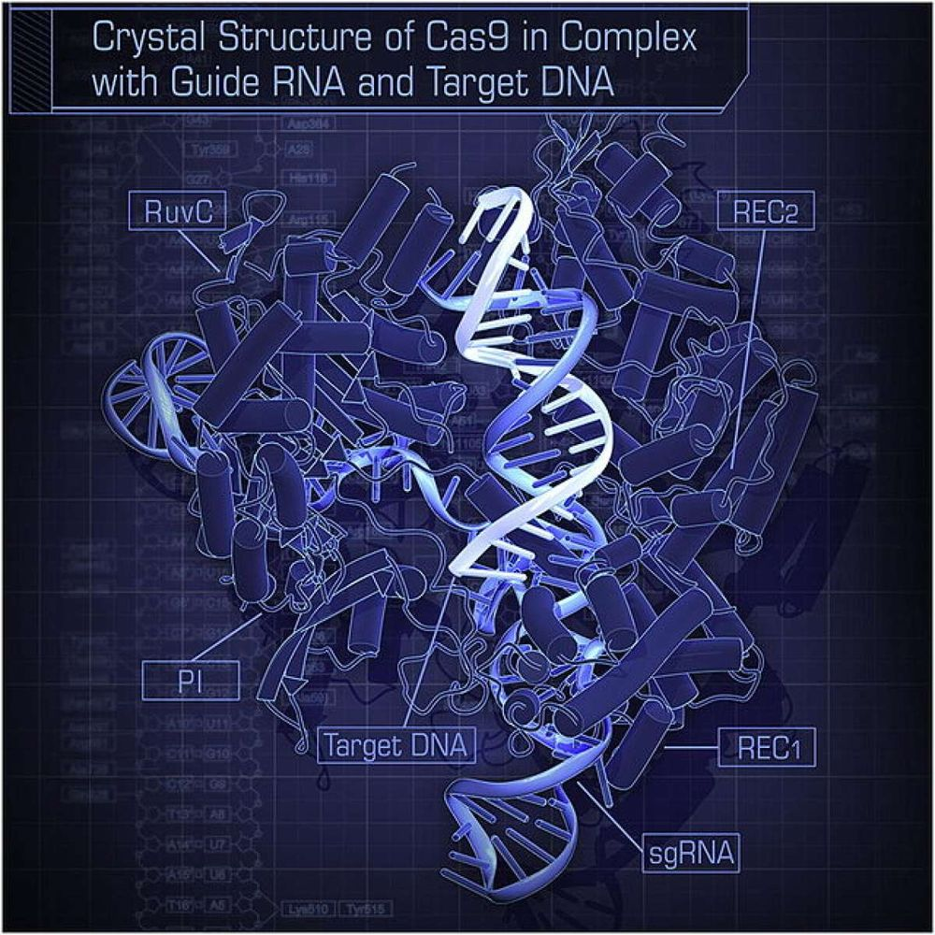
It's a complicated molecule, but CRISPR is a simple and precise way to make edits to the genetic code, which researchers in China just attempted in a human for the first time.
A simple injection in China on Tuesday was the first of its kind -- with it, researchers injected gene-edited cells into a human for the first time, using the emerging CRISPR gene-editing technique.
There's no need to worry about genetically-enhanced humans just yet, even though that's something we should maybe keep in the back of our minds. The Chinese team switched off a single gene as a possible lung cancer treatment.

The attempt is part of an ongoing Phase I clinical trial, meaning the researchers are primarily testing their technique's safety. The patient who received the injection Tuesday is one of 10 enrolled in the trial. Each patient has been diagnosed with metastatic non-small-cell lung cancer, meaning the cancer has spread to other parts of the body. According to the clinical trial details, all 10 candidates have not responded to standard treatments and have a life expectancy of six months or less.
In stepped CRISPR. In the past year, the gene-editing technique started to offer new solutions in everything from medicine to agriculture. It's cut-and-paste genetic engineering. With the technique, scientists can focus down on a single gene and fix it, tweak it, or remove it altogether.
It hadn't been tested on humans before because of the ethical concerns that it could lead to designer babies and other thorny situations. This team, lead by oncologist Lu You at Sichuan University, received ethical approval from West China Hospital's review board, where the trial is occurring, in July.
Other gene-editing techniques have been tested before on human patients, though none are as simple or precise as CRISPR.
The scientists are attempting to bolster the own body's defenses. With CRISPR, all you need is a simple snip. After drawing blood from the patient, the team targeted a specific gene in their T cells, a type of white blood cell that protects the body by attacking dangerous cells. Cancer spreads, in part, because cancerous cells are often ignored by T cells since they're made by the host's own body. The team switched off the programmed cell death protein 1 (PD-1), which normally suppresses a T cell's drive to eliminate cells with reckless abandon. The hope is that switching it off will unleash the T cells on their cancerous targets.
China has led the way on the CRISPR front. Chinese researchers were the first to use CRISPR to edit genes in a monkey, as well as in a human embryo.
The U.S. isn't far behind. The first U.S. medical trial to use CRISPR will likely be underway before the end of the year after receiving approval from the National Institutes of Health in June. Pretty soon, the latest application of CRISPR to improve human health may seem like hum-drum news.
http://www.popsci.com/crispr-tested-in-human-patient-for-first-time?con=TrueAnthem&dom=fb&src=SOC&utm_campaign=&utm_content=58b3d6a819d6ba000741f8ad&utm_medium=&utm_source=

