Name:________________________________________ P.____ Date:_____________
Notes Pg# 43: Geologic Time Scale
EQ: _______________________________________________________________
Paleontologists use _______________ to reconstruct the history of ____________. Paleo:___________ Onto:________________ Logy: ______________
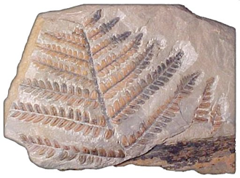
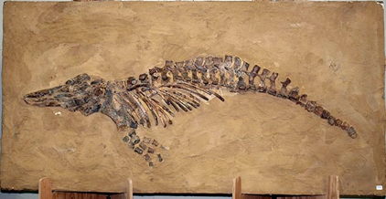
A ___________ is a trace or an imprint of a ________________ __________________ that is preserved by ______________
processes.

Fossils of ___________-____________ organisms are called _____________-_____________ and date back as far as 3.8 billion years ago (_____). These can only be seen with a ______________________.
Relative Dating
- Relative dating is used to arrange past ______________ _________________, using rocks, in a _______________. This does not give the age of the rocks.
- Relative dating determines whether a fossil formed ____________ or ____________ another fossil formed.
- ________________ fossils are found in layers of rock that are above _______________ fossils.
Absolute Dating
- In order for scientists to determine the age of ______________ they find, they
use absolute dating _____________________.
- This method gives an actual __________ or date range, in number of ___________.
- Most ________________ dates for rocks are found through ___________________ methods which use radioactive minerals in rocks as a kind of geological _________________.
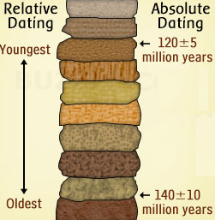
Examining the ____________ _____________ helps scientists identify when different ____________ lived and died.

Some species are present in the fossil record for a _________ period of time, while others survive for long time spans ____________ _______________________.
- Examining the ____________ ________________ helps scientists identify when different __________ lived and died.
- Some species are present in the fossil record for a ___________ period of time, while others survive for long time spans __________________________________.
- Examining the fossil records helps us determine when ________________________ occur!
Extinctions
- An ____________________ happens when every individual of a species dies.
- A ______________ ___________ occurs when a large number of species go extinct during a relatively short amount of time.
- Gradual _________________ changes and ________________ events, such as the impact of an asteroid, can cause mass extinctions.

Sixth Extinction Video Notes:

