Lab: Comparing the History of Life to a Clock
Use a straight edge to created lines showing each of the following events.
4.6 billion years in 12 hours (“Ga” is billions of years):
Origin of the Solar System and Earth: 12.01 am
First Bacteria: 7:30 am
First Cell with Nucleus (eukaryotes): 8:05 am
Animals: 9:57 pm
Land Plants: 10:13 pm
Dinosaur extinction: 11:40 pm
Human appearance: 11:59 pm Midnight
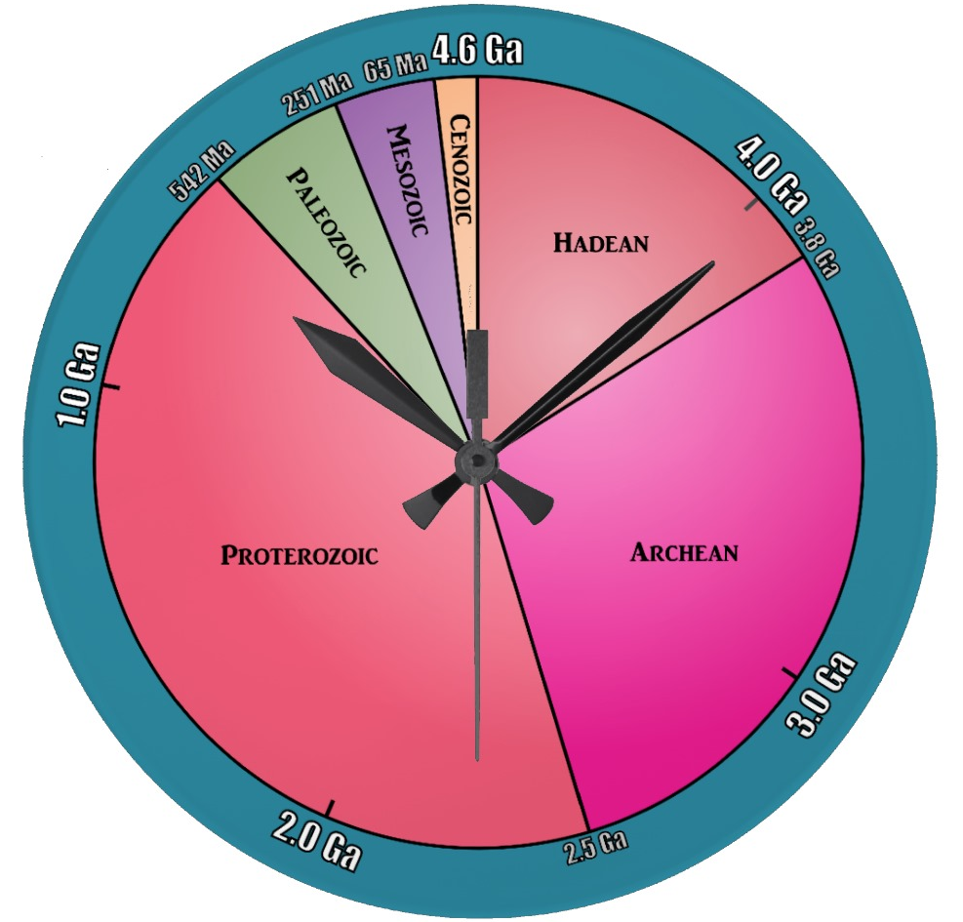

Noon

These same events can be illustrated on a yearly calendar:
**Circle or highlight and label these important dates with arrows**
First living cells - April 1st, 6pm
Algae & Marine Invertebrates - November 26th, 4:24am
Arthropods, Mollusks, first fish - December 1st, 6:36am
Many fish, trilobites, vascular plants - December 5th, 7:42am
Age of fishes, first amphibians, first insects - December 7th, 4:24am
Mosses, many amphibians, first reptiles - December 13th, 6pm
Marine Extinction, amphibian decline, Pangaea - December 14th, 2:21pm
First mammals and dinosaurs - December 16th, 10:14pm
Age of Dinosaurs, first birds - December 19th, 1:03am
Flowering plants, mass extinction - December 23rd, 5:54am
Birds and mammals flourish - December 28th, 1:09am
Hominids, ice ages, giant mammals - December 31st, 9:09pm
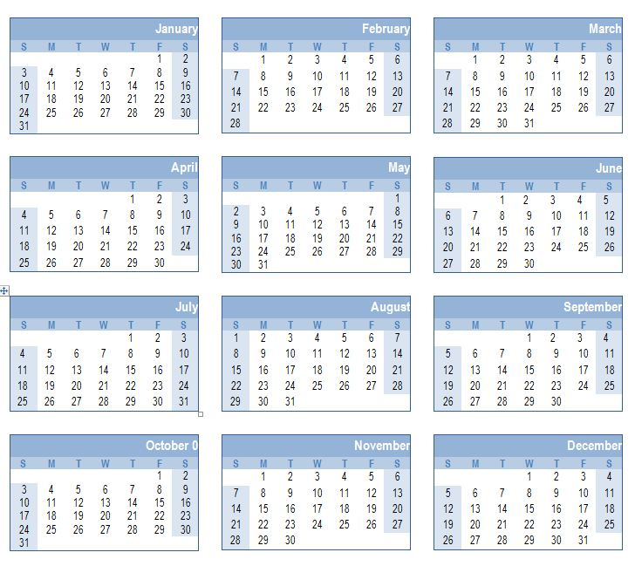
Answer: Are the events above evenly spaced through Earth’s history? Explain why the spacing seen above makes sense:

