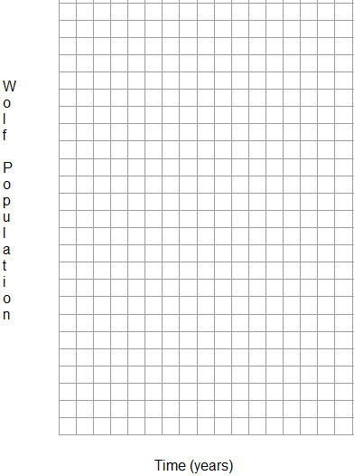
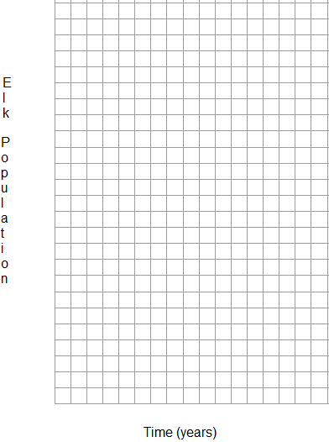
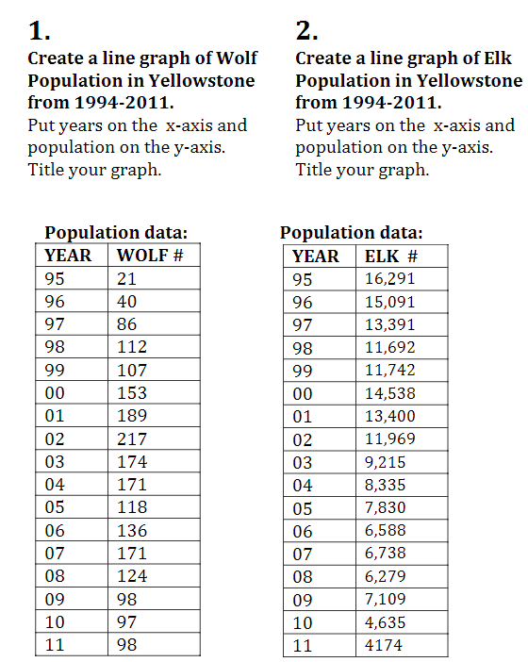
- Explain the relationship shown between the wolf and elk populations.

- Is the elk decline ONLY caused by wolves? Explain why or why not.

- Why did we graph the wolves and the elk populations separately? Is this always the case between a predator and prey population?

