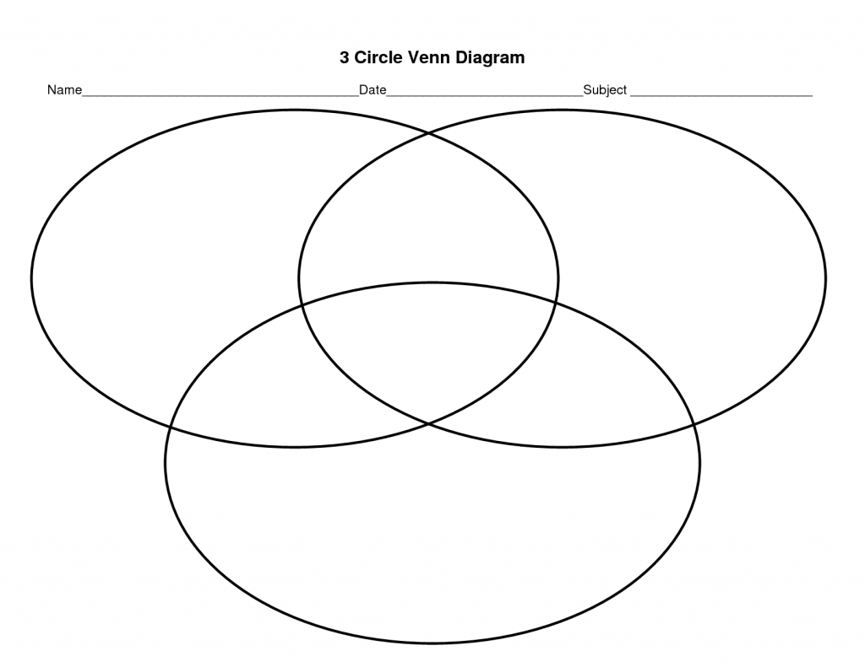
2-3 sentence Summary:

2-3 sentence Summary:

